**📄 1: Agile Meeting Overview**

Agile development relies on **structured, time-boxed meetings** to ensure transparency, collaboration, and continuous improvement. These meetings are part of the **Scrum framework**, but are also used in other Agile methodologies.

🧭 Key Agile Ceremonie:

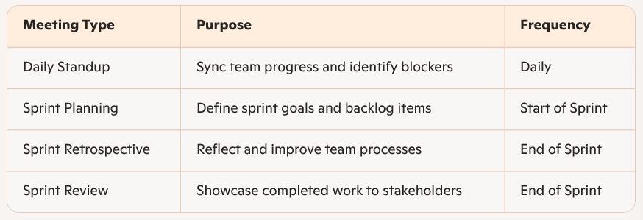

**🗂️ Agile Meeting Flow Diagram:**

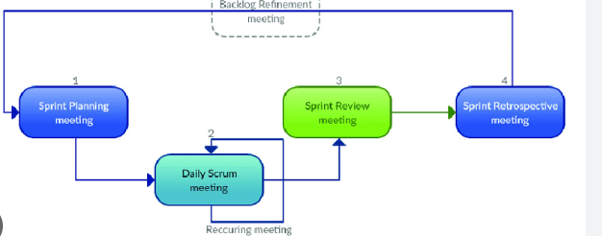

**📄 2: Daily Standup Meeting:**

🕒 Duration: 15 minutes

👥 Participants: Entire Scrum Team

🎯 Purpose

* Share progress
* Identify blockers
* Align on daily goals

📋 Format (Three Questions)

1. **What did you do yesterday?**
2. **What will you do today?**
3. **Are there any impediments or blockers?**

**🧍 Daily Standup Diagram:**

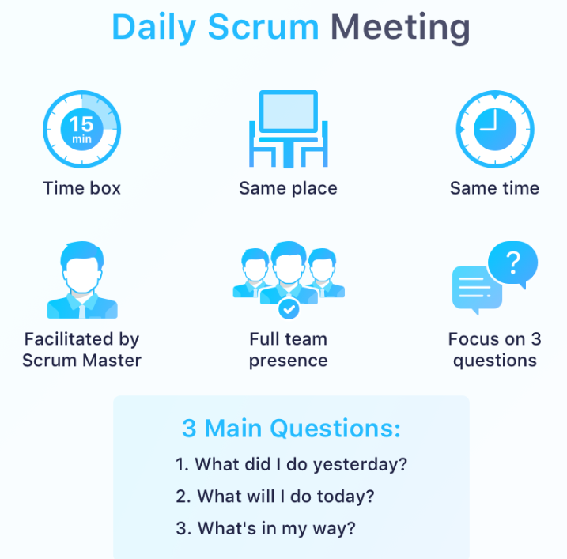

Each team member answers the three questions. The Scrum Master notes blockers and facilitates resolution.

**📄 3: Sprint Planning & Retrospective**

🧭 Sprint Planning Meeting

**When**: Beginning of the Sprint  
**Duration**: 1–2 hours (for 2-week sprint)  
**Goal**: Define sprint goal and select backlog items

🛠️ Inputs:

* Product Backlog
* Team capacity
* Past velocity

📦 Outputs:

* Sprint Goal
* Sprint Backlog

**🔄 Sprint Planning Diagram:**

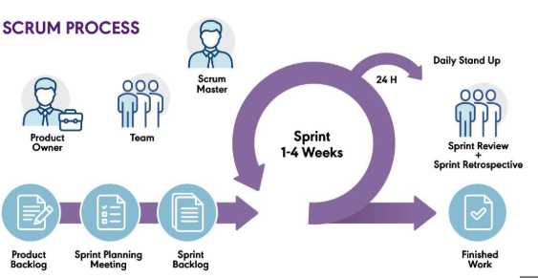

**🔍 Sprint Retrospective Meeting**

**When**: End of the Sprint  
**Duration**: 1 hour  
**Goal**: Reflect on the sprint and improve processes

🧠 Questions Discussed:

* What went well?
* What didn’t go well?
* What can we improve?

**🔁 Retrospective Diagram:**